SDD Hydronic Pumping Configurations

11/5/2013

References/Credits:

Diagrams of “Actual” systems taken from the following references:

[PG&E CoolToolsTM Chilled Water Plant Design and Specification Guide, May 2000](http://www.stanford.edu/group/narratives/classes/08-09/CEE215/ReferenceLibrary/Chillers/Chilled%20Water%20Plant%20Design%20and%20Specification%20Guide.pdf)

[Taylor S., Optimizing Design & Control Of Chilled Water Plants Part 1: Chilled Water Distribution System Selection, ASHRAE Journal, July 2011](https://www.ashrae.org/File%20Library/docLib/Committees/REF/ASHRAE-D-AJ11July01-20110705.pdf)

1. Primary Only, Single Chiller, Constant or Variable Flow

# Option 1a) Constant speed pump

## Actual

* Primary pump can be constant or variable speed.
* Pump operation interlocked with chiller operation.
* Three-way valves modulate between full flow and full bypass to maintain full flow regardless of coil demands.

## SDD

* Supply-side Chlr object reference the PrimarySupply and PrimaryReturn FluidSeg objects via EvapIn/Out reference properties.
* Primary pump assigned as child of FluidSeg:Type = PrimaryReturn (Figure 1a-2) **-or-** as child of Chlr (Figure 1a-2). Pump:Cnt represents one or more equally sized pumps piped in parallel (headered pumps). Properties to define pump staging not currently defined in SDD.
* For Primary-only systems, demand-side coils attached to PrimarySupply and PrimaryReturn via FluidSegIn/Out reference properties. Coils have three-way valves (not explicitly defined in SDD).

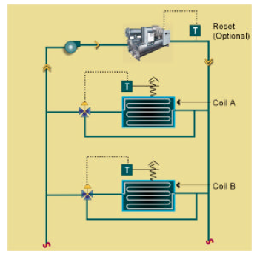

Actual 1a

**FluidSeg**

Type = PrimaryReturn

**Chlr**

HasBypass = 0

**FluidSeg**

Type = PrimarySupply

**Pump**

SpdCtrl = ConstantSpeed

Cnt = 1

SDD 1a-1

**FluidSeg**

Type = PrimaryReturn

**Chlr**

EvapHasBypass = 0

**FluidSeg**

Type = PrimarySupply

**Pump**

SpdCtrl = ConstantSpeed

Cnt = 1

SDD 1a-2

# Option 1b) Variable speed pump

## Actual

* For variable speed pumping, two-way valves are installed at most coils with just enough three-way valves installed to maintain the minimum flow required.

## SDD

* Same as 1a-1 or 1a-2 except pump is SpdCtrl = VariableSpeed and coils have two-way valves (not explicitly defined in SDD).
* Chiller should have a bypass defined, a single bypass pipe assumed to be present in parallel to chiller.

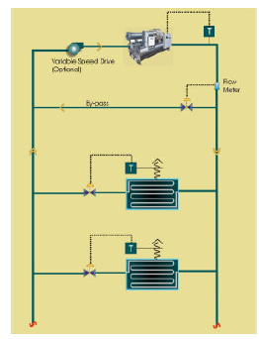

Actual 1b

**FluidSeg**

Type = PrimaryReturn

**Chlr**

EvapHasBypass = 1

**FluidSeg**

Type = PrimarySupply

**Pump**

SpdCtrl = VariableSpeed

Cnt = 1

Bypass

SDD 1b

1. Primary only, Multiple Parallel Chillers, Constant or Variable Flow

# Option 2a: Constant speed pump(s) on primary loop

## Actual

* If one chiller is OFF, flow still continues through the down machine unless a bypass is provided (shown as dashed line).
* Coils have three way valves to maintain constant flow rate.

## SDD

* Supply-side Chlr objects reference the FluidSeg:Type = PrimaryReturn and PrimarySupply objects via EvapIn/Out reference properties.
* Primary pump assigned as child of FluidSeg:Type = PrimaryReturn. Pump:Cnt represents one or more equally sized pumps piped in parallel (headered pumps). Properties to define pump staging not currently defined in SDD.
* If any of the parallel chillers have bypass defined (HasBypass = 1), a single bypass pipe assumed to be present in parallel to chiller(s). Otherwise, flow passes through down chillers to maintain constant loop flow rates.
* For primary-only systems, demand-side coils attached to PrimarySupply and PrimaryReturn via CoilClg:FluidSegIn/Out reference properties. Coils have three-way valves (not explicitly defined in SDD).

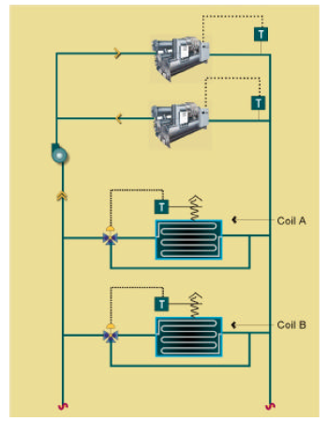

**Bypass**

Actual 2a

**Chlr** (1)

EvapHasBypass = 1 or 0

**FluidSeg**

Type = PrimaryReturn

**Chlr** (2)

EvapHasBypass = 1

**FluidSeg**

Type = PrimarySupply

**Pump**

SpdCtrl = ConstantSpeed

Cnt = 1+

Bypass

SDD 2a

# Option 2b) Constant speed, dedicated chiller pumps

## Actual

* Chiller pump OFF when chiller is OFF.
* Coils have three way valves to maintain constant flow rate.
* Works well if all coil loads change together.

## SDD

* Same as 2a) except primary pumps assigned as children of each Chlr object.
* Bypass not needed since pumps are assumed to operate only when chiller operate



Actual 2b

**Chlr** (1)

EvapHasBypass = 0

**FluidSeg**

Type = PrimaryReturn

**Chlr** (2)

EvapHasBypass = 0

**FluidSeg**

Type = PrimarySupply

**Pump**

SpdCtrl = ConstantSpeed

Cnt =1

**Pump**

SpdCtrl = ConstantSpeed

Cnt = 1

SDD 2b

# Option 2(c): Variable speed pump(s) on primary loop

## Actual

* This represents the traditional, primary-only, variable flow pumping configuration.
* Chiller typically needs a bypass to maintain minimum flow through operating chillers.

## SDD

* Same as 2a) except primary pump(s) are SpdCtrl = VariableSpeed and coils have two-way valves (not explicitly defined in SDD).
* At least one of the chillers should be defined with EvapHasBypass = 1.

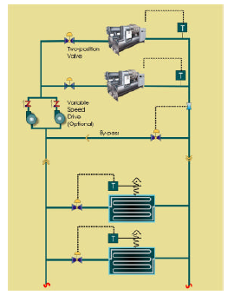

Actual 2c

**Chlr** (1)

EvapHasBypass = 1 or 0

**FluidSeg**

Type = PrimaryReturn

**Chlr** (2)

EvapHasBypass = 1

**FluidSeg**

Type = PrimarySupply

**Pump**

SpdCtrl = VariableSpeed

Cnt =1

Bypass

SDD 2c

# Option 2d) Variable speed pumps interlocked to chiller

## Actual

* Chiller pump OFF when chiller is OFF.
* Coils have two way valves.
* A bypass is required to maintain minimum flow through operating chillers.

## SDD

* Similar to 2b) except primary pumps are variable speed.
* At least one of the chillers should be defined with EvapHasBypass = 1.



Actual 2d

**Chlr** (1)

EvapHasBypass = 1 or 0

**FluidSeg**

Type = PrimaryReturn

**Chlr** (2)

EvapHasBypass = 1

**FluidSeg**

Type = PrimarySupply

**Pump**

SpdCtrl = VariableSpeed

Cnt =1

**Pump**

SpdCtrl = VariableSpeed

Cnt = 1

Bypass

SDD 2d

1. Primary/Secondary, Single or Multiple Chillers

(Single chiller configuration not included)

# Option 3(a): Constant or variable speed primary pump(s) on primary loop

## Actual

* Primary loop pumps staged or have variable speed. Here, the bypass acts as the common pipe.

## SDD

* Supply-side Chlr objects reference the FluidSeg:Type = PrimaryReturn and PrimarySupply objects via EvapIn/Out reference properties.
* Primary pump assigned as child of FluidSeg:Type = PrimaryReturn. Pump:Cnt represents one or more equally sized pumps piped in parallel (headered pumps). Properties to define pump staging not currently defined in SDD.
* At least one of the parallel piped chillers should have bypass defined (HasBypass = 1). The bypass in this case acts as the common pipe between the primary and secondary pumping loops.
* The relationship between primary and secondary FluidSegs is defined by the FluidSeg:PriSegRef property.
* Demand-side coils attached to SecondarySupply and SecondaryReturn via CoilClg:FluidSegIn/Out reference properties. Coils have two-way valves (not explicitly defined in SDD).
* Secondary pump assigned as child of FluidSeg:Type = SecondarySupply. Pump:Cnt represents one or more equally sized pumps piped in parallel (headered pumps). Properties to define pump staging not currently defined in SDD.

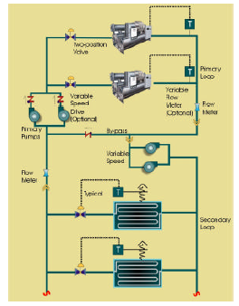

Actual 3a

**Chlr** (1)

EvapHasBypass = 1 or 0

**FluidSeg**

Type = PrimaryReturn

**Chlr** (2)

EvapHasBypass = 1

**FluidSeg**

Type = PrimarySupply

**Pump**

SpdCtrl = ConstantSpeed or VariableSpeed

Cnt = 1+

**FluidSeg**

Type = SecondarySupply

PriSegRef = PrimarySupply

**FluidSeg**

Type = SecondaryReturn

PriSegRef = PrimaryReturn

Bypass = Common Pipe

**Pump**

SpdCtrl = VariableSpeed

Cnt = 1+

SDD 3a

# Option 3(b): Constant speed primary pumps interlocked to chiller

## Actual

* Basically the same as Actual 3a, except the pumps are located on separate branches of chillers, and are interlocked to chiller operation.

## SDD

* Same as SDD 3a, except individual primary pumps are defined as children of each Chlr object.

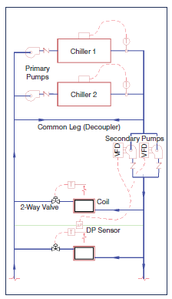

Actual 3b

**Chlr** (1)

EvapHasBypass = 1

**FluidSeg**

Type = PrimaryReturn

**Chlr** (2)

EvapHasBypass = 1

**FluidSeg**

Type = PrimarySupply

**FluidSeg**

Type = SecondarySupply

PrimSegRef = PrimarySupply

**FluidSeg**

Type = SecondaryReturn

PriSegRef = PrimaryReturn

Bypass = CommonPipe

**Pump**

SpdCtrl = VariableSpeed

Cnt = 1+

**Pump**

SpdCtrl = ConstantSpeed

Cnt = 1

**Pump**

SpdCtrl = ConstantSpeed

Cnt = 1

SDD 3b

1. Primary only or Primary/Secondary, Multiple Series Chillers

# Option 4a) Primary pump(s) on primary loop

## Actual

* Chillers piped in series. If chillers do not have bypass/isolation valves, pump primary flow assumed to pass through non-operating chillers.

## SDD

* The first Chlr object in series on the supply-side references the FluidSeg:Type = PrimaryReturn object via EvapIn reference property.
* The last Chlr object in series on the supply-side references the FluidSeg:Type = PrimarySupply object via EvapOut reference property.
* Intermediate chillers in series are connected via references to FluidSeg:Type = Connector object. The upstream Chlr:EvapOutRef and downstream Chlr:EvapInRef properties of adjacent chillers both reference the same Connector object. More than two chillers can be connected in series, but each additional series chiller requires another FluidSeg:Type = Connector object.
* Primary pump assigned as child of FluidSeg:Type = PrimaryReturn. Pump:Cnt represents one or more equally sized pumps piped in parallel (headered pumps). Properties to define pump staging not currently defined in SDD.
* If any of the parallel chillers have bypass defined (EvapHasBypass = 1), a single bypass pipe assumed to be present in parallel to chiller(s). Otherwise, flow passes through downstream chiller(s) to maintain constant loop flow rates. Separate bypasses for individual chillers is not explicitly supported.
* For primary-only systems, demand-side coils attached to PrimarySupply and PrimaryReturn via FluidSegIn/Out reference properties. Coils have three-way valves (not explicitly defined in SDD).

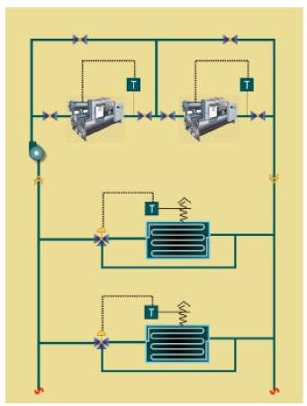

Actual 4a

**Chlr** (2)

EvapHasBypass =

1 or 0

**FluidSeg**

Type = PrimaryReturn

**Chlr** (1)

EvapHasBypass =

1 or 0

**FluidSeg**

Type = PrimarySupply

Bypass

**Pump**

SpdCtrl = ConstantSpeed

Cnt = 1+

**FluidSeg**

Type = Connector

SDD 4a

# Option 4b) Primary pumps interlocked to chiller

## Actual

* Sames as Actual 4a except the pumps are located in series with chillers on separate branches, and all chillers share a common bypass.

## SDD

* Same as SDD 4a, except individual primary pumps are defined as children of each Chlr object.

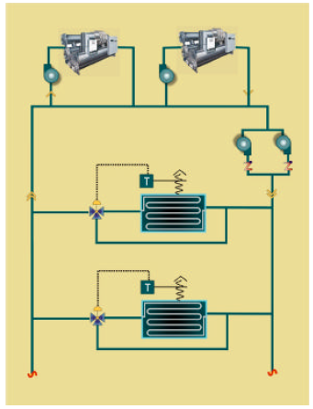

Actual 4b

**Chlr** (2)

EvapHasBypass = 1

**FluidSeg**

Type = PrimaryReturn

**Chlr** (1)

EvapHasBypass = 1

**FluidSeg**

Type = PrimarySupply

Bypass

**Pump**

SpdCtrl = ConstantSpeed

Cnt = 1

**FluidSeg**

Type = Connector

**Pump**

SpdCtrl = ConstantSpeed

Cnt = 1

SDD 4b

1. Primary/Secondary Variable Flow Piping, Tertiary Pumping

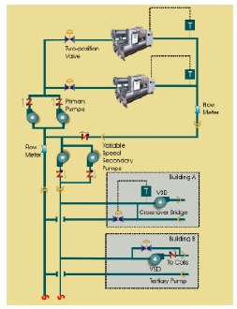

Actual 5a

*SDD definition not defined yet, but will basically be the same as 3a or 3b, with additional FluidSeg:Type = SecondarySupply/Return objects that represent the tertiary pumping loops. Instead of referencing the primary loops, the secondary FluidSeg objects would be referenced by the Tertiary objects via the PriFluidSegRef properties.*